PHASE II: PROJECT PLANNING
Date | 05 November 2025
Team ID | NM2025TMID03595
Project Name | Garage Management Application
Maximum Marks | 4 Marks

Title: Project Planning for “Garage Management Application – A Salesforce-Based Workshop Automation System”

1. Objective
The Project Planning Phase establishes the foundation for designing and developing the Garage Management System. Its objective is to analyze business requirements, define data models, plan user roles, and design secure access configurations to ensure a stable and efficient Salesforce implementation.
This phase defines the logical structure, relationships, and security hierarchy necessary for seamless automation of garage operations such as service booking, maintenance tracking, and billing management.

2. Overview of the Planning Process
The planning phase involves the following key steps:
- Defining Core Entities and Relationships
- Designing Security and Data Sharing Models
- Creating User Roles and Assigning Permissions
- Establishing the Development Timeline and Tools
These activities ensure that the entire system architecture aligns with the technical feasibility and business goals of automating garage services through Salesforce.
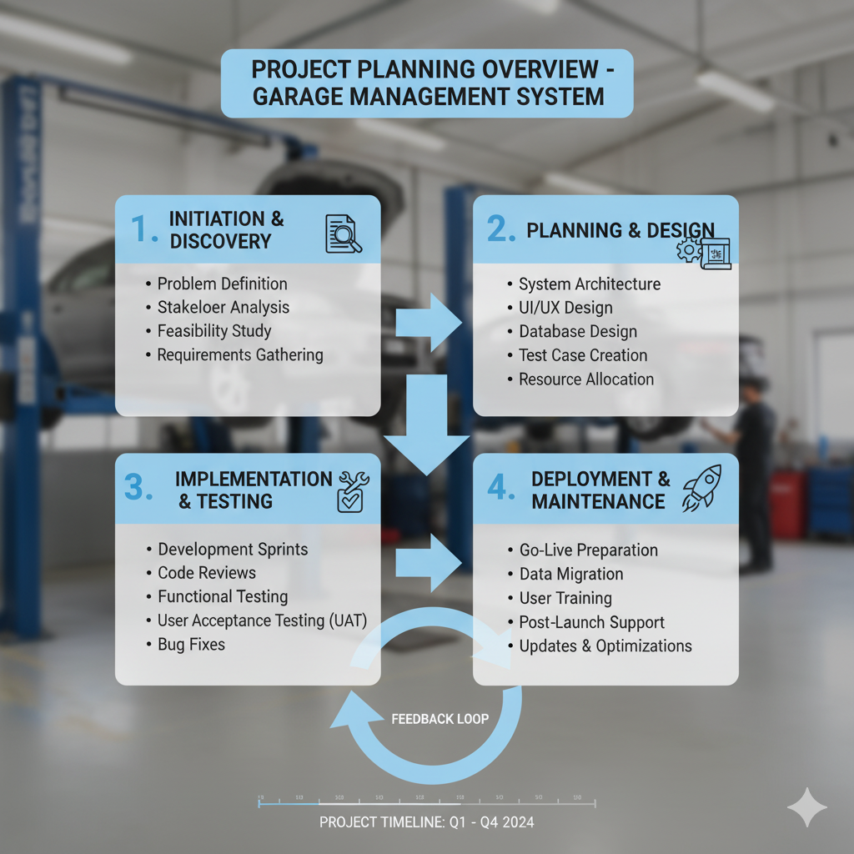

3. Core Entity Identification
The Garage Management Application is built around five key custom objects, each representing a major function of a modern workshop.
Object Name | Description | Relationships
Customer Details | Stores customer personal and contact information. | Linked to Appointment and Billing Details
Appointment | Captures vehicle booking and service details. | Linked to Customer Details and Service Records
Service Records | Maintains logs of the services performed on vehicles. | Linked to Appointment
Billing Details & Feedback | Contains service payment info and customer feedback. | Linked to Service Records
Vehicle Details | Stores information about customer vehicles. | Linked to Customer Details
These entities ensure smooth tracking from customer registration → appointment → service completion → billing and feedback.

4. Relationship Strategy
The relationships between objects were structured to maintain data integrity and enable process automation.
Relationship Type | Object Pair | Purpose
Master-Detail | Appointment → Service Records | To automatically remove child records when an appointment is deleted.
Lookup | Customer Details → Vehicle Details | To associate multiple vehicles with a single customer.
Formula |  | To connect each service to its corresponding payment and feedback.
  Service Records → Billing Details

This setup ensures efficient record linking, supports automation through Flows and Triggers, and maintains referential integrity across the system.

5. Security and Profile Planning
The Salesforce Security Model was implemented to ensure that data access is role-based and adheres to the principle of least privilege.

5.1 Custom Profiles Created
Profile Name | Description | Access Level
Manager Profile | Used by garage managers for complete access to all records. | Full CRUD access
Sales Person Profile | Used by staff handling appointments and billing. | Read, Create, Edit on assigned objects.

Each profile was cloned and customized from standard Salesforce profiles to enforce role-based access control.

5.2 Public Groups
To streamline record visibility and sharing:
Public Group | Members | Purpose
Sales Team | Salesperson users | Manage appointment bookings and payments.
Service Team | Technicians | Update vehicle service records and status

This configuration enables efficient collaboration while keeping sensitive customer and financial data secure.

6. Data Access and Sharing Rules
Criteria-based sharing rules were applied to maintain proper access control:
- If Service Status = Completed, record shared with Manager role.
- If Payment Status = Pending, record shared with Salesperson role.
Rationale:
This ensures that managers can oversee completed tasks, while sales personnel can follow up on pending payments—reducing operational errors and improving accountability.

7. User Creation and Role Assignment
User creation followed a systematic process within the Salesforce setup:

7.1 Procedure
- Go to Setup → Users → New User.
- Enter required details (Name, Email, Username).
- Assign Salesforce License for Managers and Salesforce Platform License for Salespersons.
- Assign corresponding Profiles and add users to relevant Public Groups.

7.2 User Hierarchy
Role | Assigned Profile | Group | Privileges
 | Manager Profile | Sales Team
  Manager
  Full access to all modules
Salesperson | Sales person Profile | Sales Team | Limited record access
Technician |  | Service Team | Update-only access
  Technician Profile
System Admin | Standard Admin | N/A | Full Setup & Configuration

8. Environment Setup and Configuration
Steps followed to prepare the development environment:
- Created Salesforce Developer Edition account from developer.salesforce.com/signup.
- Enabled Lightning Experience for enhanced UI.
- Configured organization name as Garage Management Application.
- Created custom tabs for all key objects.
- Installed standard tools — Flow Builder, Schema Builder, App Manager, and Report Builder for configuration.
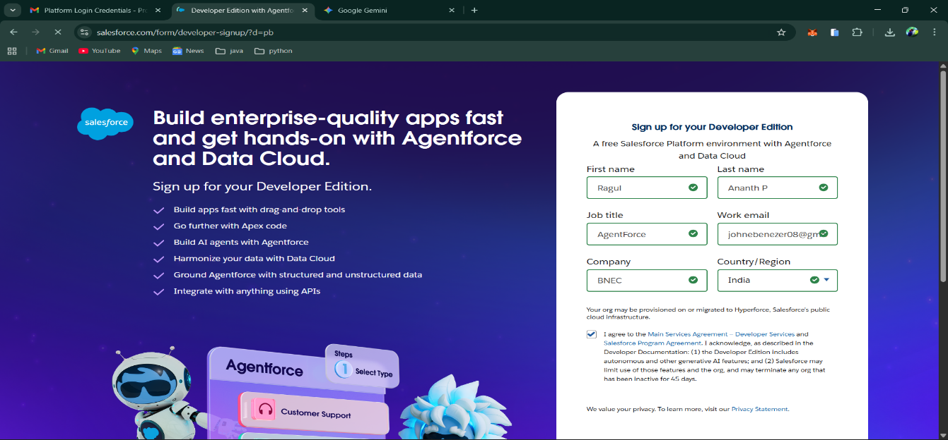

9. Project Timeline and Resource Plan
Phase | Duration | Key Deliverables
Ideation | 2 Days | Problem Definition, Feature List
Planning | 3 Days | Data Model, Security Model, User Roles
Requirement Analysis | 4 Days | Object Creation, Relationship Setup
Design & Implementation | 5 Days
  Flows, Triggers, UI & Dashboards
Testing & Deployment | 2 Days | Validation, Reports, and Feedback Collection

10. Tools and Resources Used
Tool | Purpose
Salesforce Lightning App Builder | To design UI and navigation
Flow Builder | To automate service and billing processes
Apex Trigger | To automate field updates (e.g., Service Status)
Dashboard Builder
  To create visual insights for performance tracking
Schema Builder | To define relationships and ER diagrams
SmartInternz Platform | For project collaboration and submission tracking

11. Expected Outcomes of the Planning Phase
By the end of this phase:
- Core entities and relationships were clearly defined.
- Security profiles and user roles were implemented.
- Developer environment and UI components were configured.
- Clear workflow and reporting structures were established.
This provided a stable foundation for the Requirement Analysis and Design Phase.
📍 [Figure 2.7: Planning Workflow Diagram – Setup to Implementation]

12. Summary
The Project Planning Phase served as the blueprint for the successful development of the Garage Management System.
Through careful structuring of entities, user roles, and automation logic, the project ensured scalability, data consistency, and operational transparency.
Salesforce’s flexibility enables the Garage Management Application to automate service operations, reduce manual work, and improve customer experience—making this phase the backbone of the entire implementation.

